Experiment 8

Describe major services (functionality) provided by a hospital's reception.

Summary: Hospital Management System is a large system including several

subsystems or modules providing variety of functions. Hospital Reception subsystem

or module supports some of the many job duties of hospital receptionist. Receptionist

schedules patient's appointments and admission to the hospital, collects information

from patient upon patient's arrival and/or by phone. For the patient that will stay in the hospital ("inpatient") she or he should have a bed allotted in a ward. Receptionists might also receive patient's payments, record them in a database and provide receipts, file insurance claims and medical reports.

Aim:

To describe the major services (functionality) provided by a hospital’s reception as part of a Hospital Management System (HMS) and outline its workflow.

Procedure:

Step 1: Identify Key Responsibilities of the Hospital Reception

The hospital reception module handles patient appointments, admissions, records management, and billing. Key responsibilities include:

Scheduling Patient Appointments

Book appointments via phone or in-person.

Reschedule or cancel appointments.

Assign doctors based on availability.

Patient Registration & Information Collection

Collect personal and medical details.

Maintain electronic medical records (EMR).

Verify patient insurance details.

Inpatient Admission & Bed Allocation

Assign patients to wards/beds.

Record admission details.

Coordinate with medical staff for room availability.

Billing & Payments Processing

Accept payments from patients.

Generate and provide payment receipts.

Maintain records of financial transactions.

Insurance & Medical Reports Processing

File insurance claims.

Assist in medical documentation.

Provide reports for further medical processes.

Step 2: Define the Workflow of the Hospital Reception System

Patient Walks In / Calls for Appointment

Receptionist schedules an appointment in the system.

Patient Registration & Check-in

Receptionist collects personal & medical details.

Records details in Hospital Management System (HMS).

Admission for Inpatient

Assigns a bed/ward if the patient is to be hospitalized.

Billing & Payment Processing

Patient makes payment, receipt is generated.

Insurance claims are filed if applicable.

Medical Reports & Documentation

Receptionist handles patient reports and documentation.

Step 3: Ensure System Integration

The Reception Module must integrate with:

Doctor’s Schedule (to allocate appointments).

Bed Management System (for inpatient admission).

Billing System (for payments and receipts).

Insurance Processing System (for claim processing).

Output:

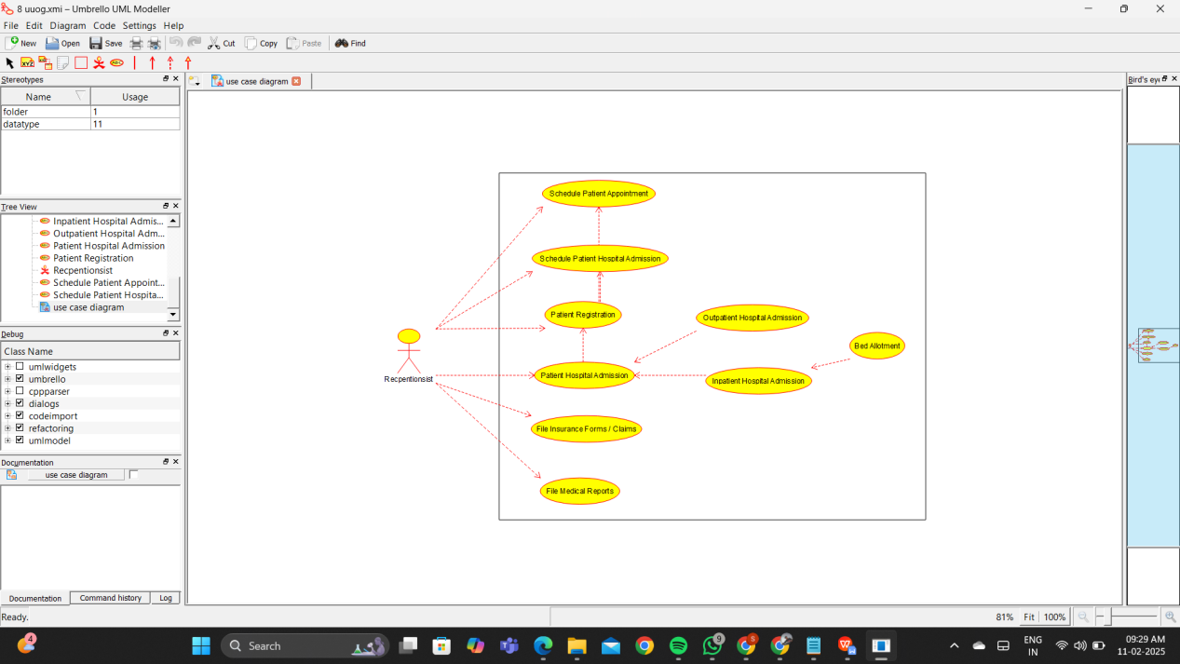

Result:

Thus the UML diagram has been implemented successfully.